Pipeline for Docker Image Build and Push to JFrog
K M Chandrashekhar Repo: https://github.com/kmcdevops/test-jfrog
Setup Jenkins and Docker
Commands:
sudo apt update
sudo apt install openjdk-17-jdk -y
wget -q -O - https://pkg.jenkins.io/debian/jenkins.io.key | sudo apt-key add -
sudo sh -c 'echo deb https://pkg.jenkins.io/debian-stable binary/ > /etc/apt/sources.list.d/jenkins.list'
sudo apt update
sudo apt install jenkins -y
sudo systemctl start jenkins
sudo systemctl status jenkins
sudo apt install docker.io -y
sudo systemctl start docker
sudo systemctl enable docker
docker –version
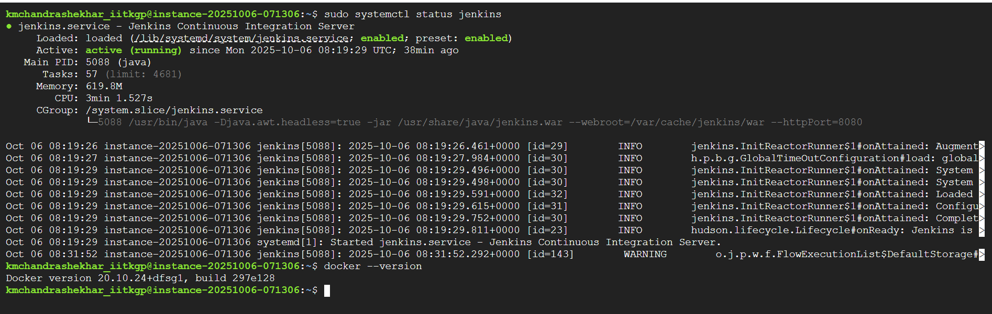
- GitHub Repository Setup
- Repo name: test-jfrog
- Added files: Jenkinsfile, Dockerfile, README.md
Commands:
git clone https://github.com/kmcdevops/test-jfrog.git
cd test-jfrog
# Add Dockerfile
git add Dockerfile
git commit -m "Add Dockerfile for Jenkins pipeline"
git push origin main
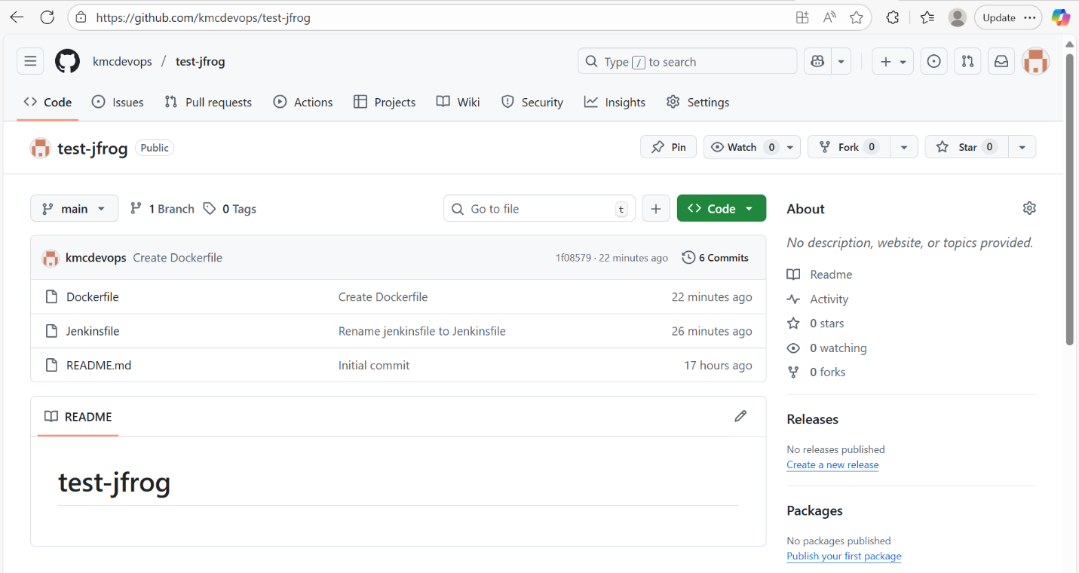
- JFrog CLI Configuration
Commands:
curl -fL https://getcli.jfrog.io | sh
sudo mv jfrog /usr/local/bin/
jfrog --version
jfrog config add art1 \
--artifactory-url=https://triali5hfv3.jfrog.io/artifactory \
--user=kmcdevops2025@gmail.com \
--password=<API-TOKEN> \
--interactive=false
echo "JFrog connection successful" > test.txt
jfrog rt upload "test.txt" "docker-local/test.txt" --server-id=art1
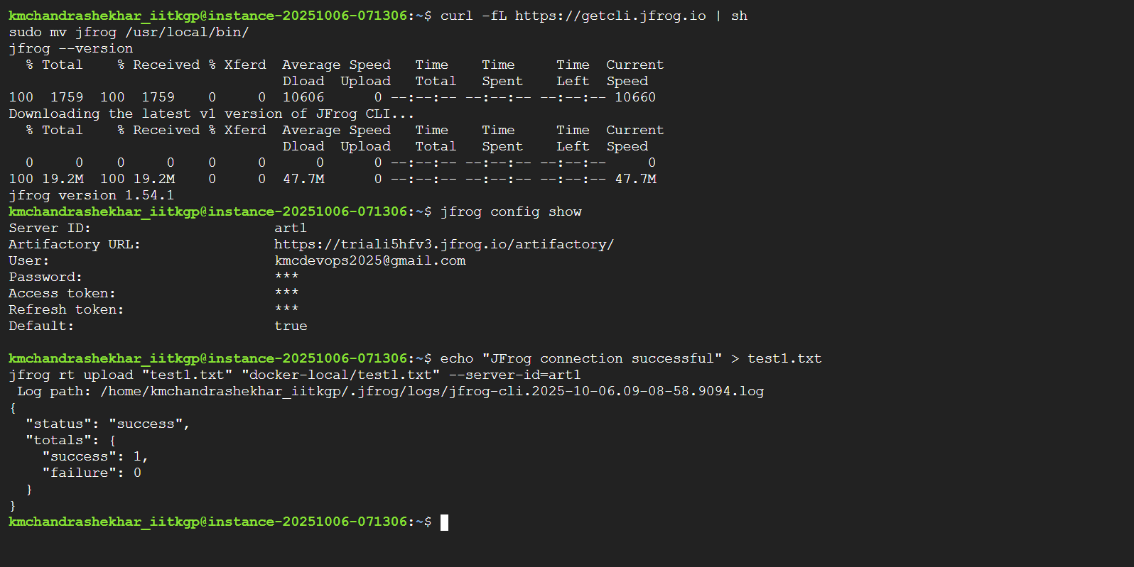
- Jenkins Pipeline Setup

pipeline {
agent any
environment {
JFROG_URL = 'https://triali5hfv3.jfrog.io/artifactory'
JFROG_REPO = 'docker-local'
IMAGE_NAME = 'demo-image'
IMAGE_TAG = '1.0'
CREDENTIALS_ID = 'jfrog-creds'
}
stages {
stage('Checkout') {
steps {
git branch: 'main', url: 'https://github.com/kmcdevops/test-jfrog.git'
}
}
stage('Build Docker Image') {
steps {
script {
sh 'docker build -t $IMAGE_NAME:$IMAGE_TAG .'
}
}
}
stage('Tag Docker Image for JFrog') {
steps {
script {
sh 'docker tag $IMAGE_NAME:$IMAGE_TAG triali5hfv3.jfrog.io/$JFROG_REPO/$IMAGE_NAME:$IMAGE_TAG'
}
}
}
stage('Login to JFrog and Push') {
steps {
withCredentials([usernamePassword(credentialsId: "${CREDENTIALS_ID}", usernameVariable: 'USERNAME', passwordVariable: 'PASSWORD')]) {
sh 'docker login -u $USERNAME -p $PASSWORD triali5hfv3.jfrog.io'
sh 'docker push triali5hfv3.jfrog.io/$JFROG_REPO/$IMAGE_NAME:$IMAGE_TAG'
}
}
}
}
}
Jenkins Job Steps: 1. New Item → Pipeline → Name: JFrog-Docker-Pipeline 2. Pipeline script from SCM → Git → Repo URL → Branch: main → Script Path: Jenkinsfile 3. Add Credentials (jfrog-creds) → Username: kmcdevops2025@gmail.com, Password: JFrog API token
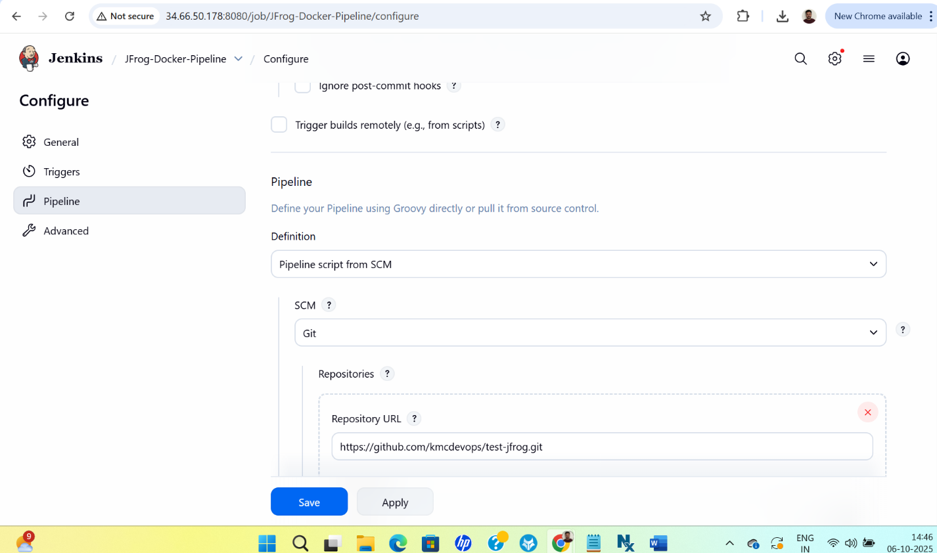

- Run Pipeline
Pipeline stages: | Stage | Status | |——-|——–| | Checkout | ✅ Success | | Build Docker Image | ✅ Success | | Tag Docker Image | ✅ Success | | Login & Push to JFrog | ✅ Success |
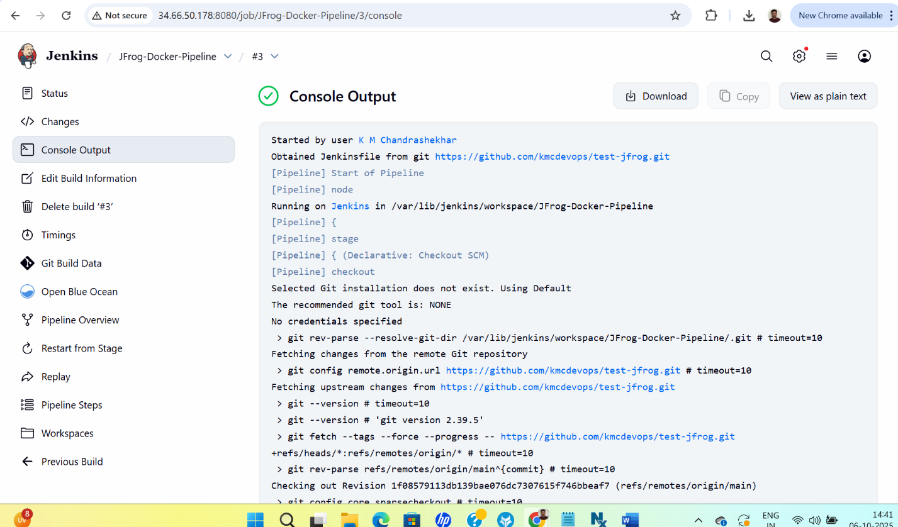
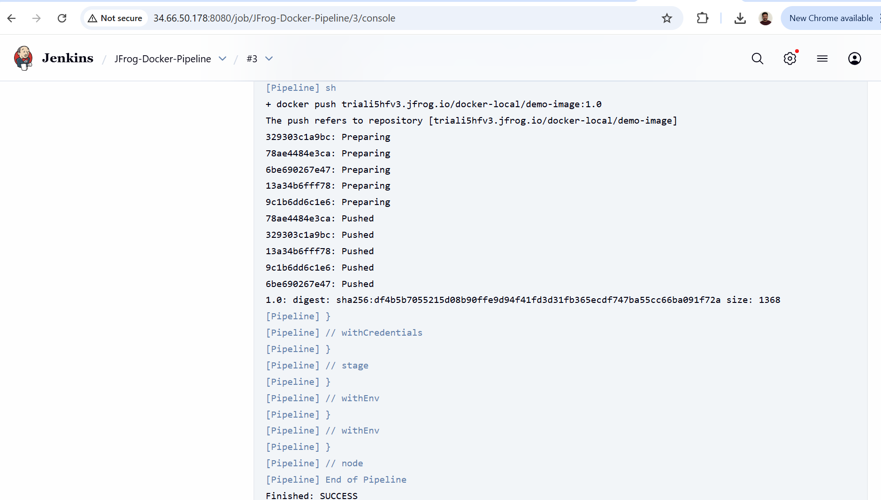

- Verify Docker Image in JFrog
- Go to: https://triali5hfv3.jfrog.io/ui/repos/tree/General/docker-local
- Image: demo-image:1.0 should appear
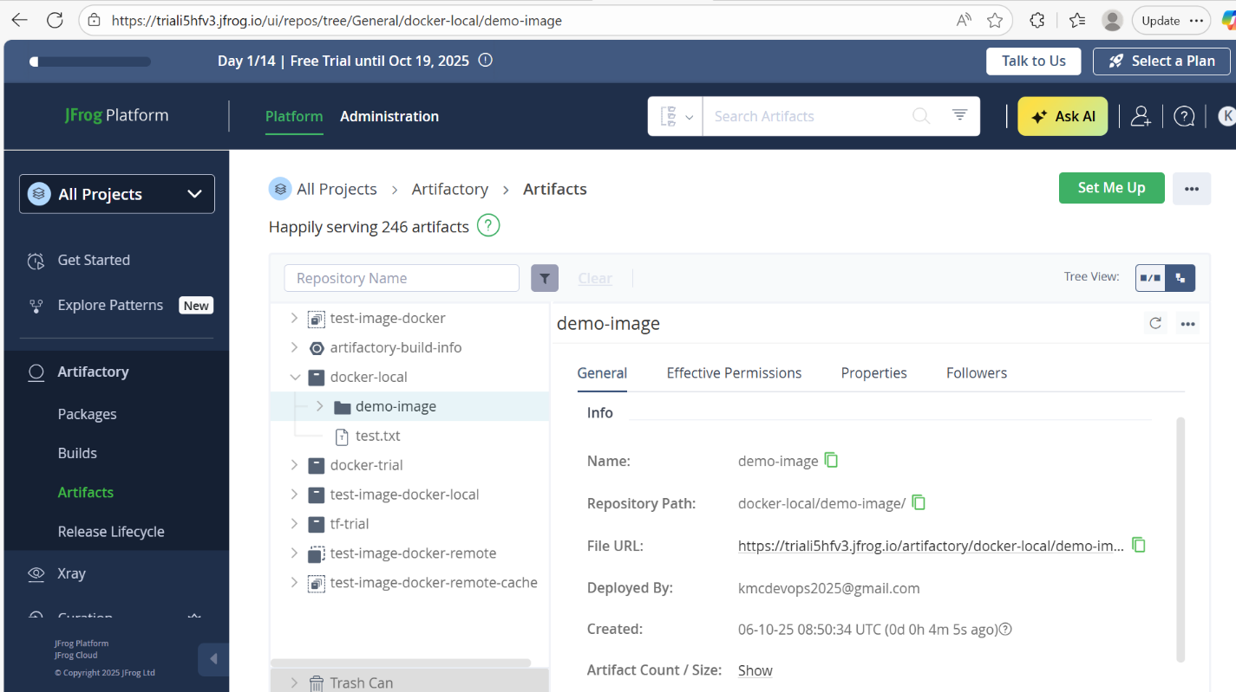

- Summary
- Jenkins pipeline successfully automates Docker build and push
- GitHub repo stores all source and pipeline files
- JFrog Artifactory stores the Docker image artifact

